IANR Annual Merit Recommendation Form (Merit Form)
Date Completed:

Supervisor Name: | Department:

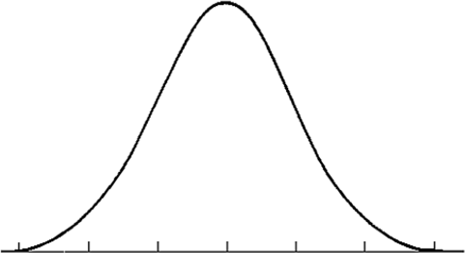
Fulfilled Performance Expectations; consistently met expectations; at times may exceed expectations

1/24/2020

Somewhat meets and somewhat does not meet expectations; improvement needed
Consistently Exceeded Expectations; performed above and beyond

Did Not Meet Expectations

Exceptional Performance; performance far exceeded expectations

NOTE: Rows can be added or removed in each section as needed depending on the number of employees supervised. It is possible
there will not be any employees listed every section. This information will be shared with unit administrators to make salary determinations.
List the name(s) of the employee(s) and justification(s)for exceptional performance rating.
EXCEPTIONAL PERFORMANCE
- Performance far exceeded expectations in all key areas of responsibility with exceptionally high quality of work and exceptional or unique contributions to organizational objectives
- Behavior consistently exemplified the highest values of the organization
- This rating is not given frequently
Employee Name(s) | Justification(s)

List the name(s) of the employee(s) for each of the following ratings. No additional justification is needed on this form for employees in these areas.
SOMEWHAT MEETS/DOES NOT MEET |  | FULFILLED EXPECTATIONS |  | CONSISTENTLY EXCEEDED EXPECTATIONS
- Performance did not consistently meet job requirements  - Meets majority but not all expectations  - Behavior may not consistently reflect the essential organizational values  - This performance rating would typically follow on-going counseling and coaching for improvement. |  | - Performance consistently met expectations in key areas of responsibility; at times may exceed expectations. The overall quality of work was good  - Is dependable, highly reliable, follows through on assignments  - Exhibited behavior consistent with the values of the organization |  | - Performance consistently exceeded expectations in key areas of responsibility, and the quality of work was generally excellent  - Exhibited model behavior that reflected the values of the organization
Employee Name(s) |  | Employee Name(s) |  | Employee Name(s)

List the name(s) of the employee(s) and justification(s) for did not meet expectations rating. This rating should not be a surprise to the employee. You should have/maintain adequate documentation to support/show meetings and notification to the employee about expectations not being met. For each employee listed, please note whether you have contacted IANR HR to assist you with addressing the employee’s performance concerns.
DID NOT MEET EXPECTATIONS
- Failed to meet essential performance expectations
- Lack of improvement would likely be previously documented through progressive discipline
- Behavior may be contrary to essential organizational values
- Repeated overall annual ratings of “Did Not Meet and Somewhat Meets/Does Not Meet” should not be tolerated. Improvement is essential for continued employment. A plan to improve performance must follow and include clear expectations, deadlines, and formally scheduled
one-on-one reviews for measuring the expected improvements
Employee Name(s) | Justification(s) | IANR HR  (yes/no)

Final date to return form is March 31 or as directed by your business center.

